**ARECA NUT DISEASE DETECTION**

**Abstract:**

Arecanut, commonly known as betel nut, is a significant tropical crop, with India being the second-largest producer and consumer globally. The crop is vulnerable to a range of diseases throughout its life cycle, traditionally detected through manual observation, which is labor-intensive and subjective. This paper proposes a novel system utilizing Convolutional Neural Networks (CNNs) for the automatic detection of diseases in arecanut plants, including their leaves and trunks, while also providing suggested remedies. A custom dataset comprising 250 images of both healthy and diseased arecanut was created, with a training-testing split of 80:20. The CNN model was compiled using categorical cross-entropy as the loss function and the Adam optimizer, trained over 50 epochs to maximize validation and test accuracy while minimizing loss. The proposed approach demonstrated an effectiveness rate of 88.46% in accurately identifying arecanut diseases, highlighting the potential of deep learning in enhancing agricultural disease management.

**Chapter 1:**

**INTRODUCTION**

Areca nut, also known as betel nut, is the seed of the Areca palm (Areca catechu), primarily cultivated in tropical regions of South and Southeast Asia. It is commonly chewed alone or wrapped in betel leaves along with slaked lime and other ingredients, forming a traditional preparation known as "paan." Areca nut plays a significant role in cultural rituals, social customs, and economies in many regions. However, excessive consumption has been associated with health risks, including oral cancer and other diseases. The crop is also prone to various diseases, such as fruit rot and yellow leaf disease, which can impact yield and quality. Areca nut is based on size, color, shape and region. It is grown in many parts of Karnataka like Shivamogga, Davangere, Chitradurga, Chikmagalur and other places.

* 1. **OBJECTIVES**
* To identify and extract key features using image processing.
* To implement AI-Driven Image Analysis for Accuracy.
* To enhance food security and sustainability.
* To facilitate Real-Time Data Transfer and Analysis.
* To reduce economic loss due to diseased.
  1. **PROBLEM STATEMENT**

The manual classification of areca nuts as diseased or normal by farmers is labor - intensive and susceptible to inaccuracies. By leveraging image processing techniques, this process can be automated, enabling precise analysis of areca nut images to swiftly and accurately identify diseased and healthy nuts, thereby improving efficiency and consistency in quality assessment.

* 1. **SCOPE OF THE PROJECT**
* **Creation of a Labelled Image Database:** A comprehensive, labelled database of both healthy and diseased areca nut images will be created. This database will serve as the foundation for training and testing the detection algorithms, enhancing the reliability and performance
* **Data collection and pre-processing**: Gather a comprehensive dataset of areca nut images, including both diseased and healthy specimens. This will involve data cleaning, augmentation, and labelling to ensure high-quality inputs for the image processing algorithms.
* **Image Processing and Classification:** Develop and implement image processing system's techniques, such as feature extraction and machine learning algorithms, to accurately classify areca nuts as diseased or normal based on their visual characteristics.
* **User Interface Development:** Create an intuitive user interface that allows users to easily upload images of areca nuts, view classification results, and access detailed information about the health status of the nuts.
* **Deployment of solution:** Deploy the final solution in a real-world environment, providing support to users, such as farmers and quality control personnel, to ensure effective use of the system for areca nut classification.

**CHAPTER 2**

**LITERATURE SURVEY**

* Meghana D R et.al: In this paper, the proposed work is to detect the diseases using Convolutional Neural Network (CNN) and recommends solutions for it. CNN it takes image as an input and assign the learnable weights to objects of the images and learns the result to classify the images one from another.
* Dhanuja K C et.al: The texture-based grading of the areca nut is suggested in this paper. Applications of Wavelet, Gabor, LBP, GLDM and GLCM are used to extract various texture features from areca nut. The Nearest Neighbor (NN) system is used. Experimentation with a dataset of 700 images from 7 classes to illustrate the efficiency of the proposed model.
* Sushmita S et.al: We suggest a method that automatically categorizes areca nuts based on unprocessed photos with husks using image processing techniques. To extract features from areca nut images, our system uses segmentation using the Otsu method and the GLCM texture feature extraction approach. Based on the recovered texture data, we classify the areca nuts using both Convolutional Neural Networks (CNNs) and decision trees.

**CHAPTER 3**

**METHODOLOGY**

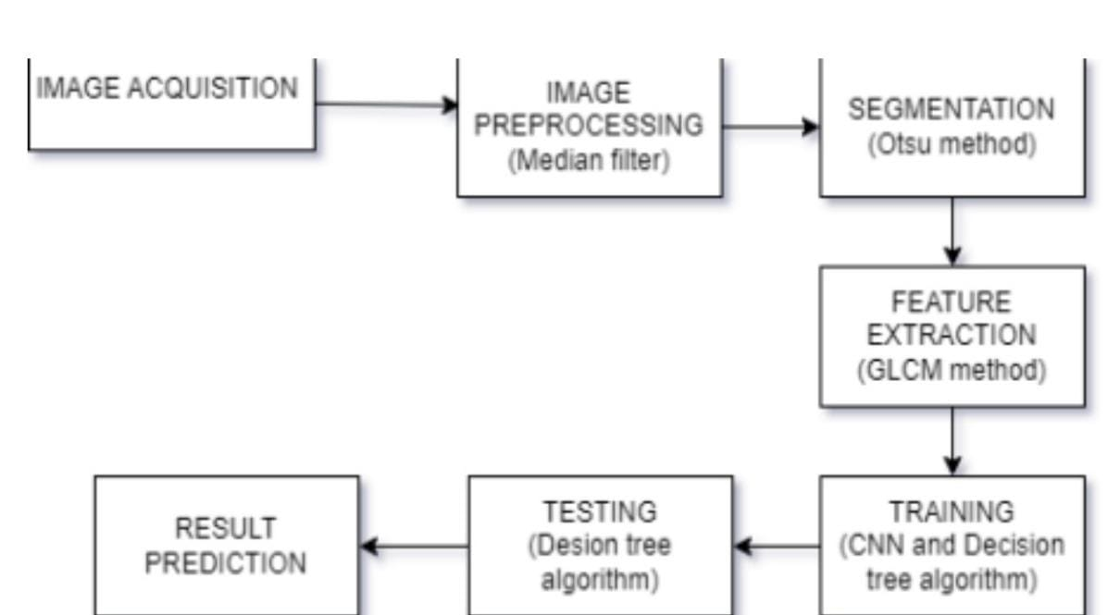

**Fig. 3.1 Architecture diagram**

* **Image Acquisition:** This is the first step, where images of Areca Nut are captured for analysis. The quality and resolution of the acquired images are critical as they serve as input for the entire system.
* **Image Pre-processing (Median Filter):** In this stage, image pre-processing techniques are applied to enhance the image and remove any noise. A median filter is used, which helps to reduce noise while preserving the edges of the image, leading to clearer and more accurate segmentation.
* **Segmentation (Otsu Method):** Segmentation is used to separate the diseased parts of the nut from the healthy regions. The **Otsu method** is an automatic thresholding technique used for image segmentation, where it separates the foreground (diseased area) from the background (healthy area) by choosing an optimal threshold value based on image histogram analysis.
* **Feature Extraction (GLCM Method):** After segmentation, the GLCM (Grey Level Co-occurrence Matrix) method is used to extract features from the segmented regions. GLCM is a popular method for texture analysis that helps in quantifying the spatial relationships between pixels in an image, which can provide insights into the texture of the disease-affected areas.
* **Training (CNN and Decision Tree Algorithm):** The features extracted in the previous step are used for training a model. The system employs Convolutional classification, and a Decision Tree Algorithm, which is a classification technique used for making decisions based on the features. These models learn to differentiate between healthy and diseased areas based on the training data.
* **Testing (Decision Tree Algorithm):** In the testing phase, new images are processed using the trained model to test its performance. The Decision Tree Algorithm is applied again to classify the images based on the learned features.
* **Result Prediction:** Finally, the system predicts whether the Areca Nut in the image is diseased or healthy based on the results of the testing phase. This architecture represents a combination of image processing, machine learning, and classification techniques to automatically detect diseases in Areca Nut crops.

**CHAPTER 4**

**EXPECTED OUTCOMES**

* **Automated Classification:** A reliable and efficient automated system capable of accurately classifying areca nuts as diseased or normal, significantly reducing the need for manual inspection.
* **Improved Accuracy:** Enhanced accuracy in detecting diseased nuts compared to manual classification, leading to better quality control and reduced economic losses for farmers.
* **User-Friendly Interface:** A well-designed user interface that allows users to easily upload images, view results, and understand the classification process, promoting wider adoption among farmers and agricultural workers.
* **Data-Driven Insights:** Generation of valuable insights from the analysis, enabling farmers to make informed decisions about crop management, disease prevention, and resource allocation.

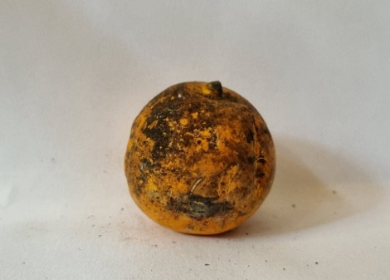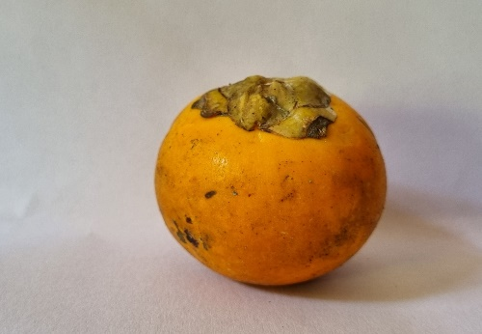

**Fig 3.2 Healthy Areca Nut Fig 3.3 Diseased Areca Nut**

**Reference:**

**[1].** Anilkumar MG, karibasaveshwara TG,in Arecanut using Convolutional Neural Networks, International Research Journal of Engineering and Technology(IJERT) Volume:08 Issue:05 May 2021.

**[2].** Dhanuja K C , Mohan Kumar H P, 2020, Areca Nut Disease Detection using Image Processing Technology, International Journal of Engineering Research & Technology(IJERT) volume 09,issuse 08(August 202).

**[3].** Mallikarjuna SB, et al: Multi-gradient-direction based deep learning model for areca disease identification .CSSI Trans .Intrll.Technol.7(2),156-166(2022).